SUBMIT SHIRT INFO BELOW
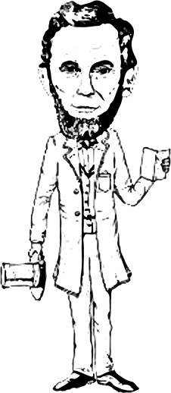
Drinkin’ with Lincoln 2020
Historic Pub Crawl
Downtown Lemont
February 7, 2020  6:30 p.m. | Pick up shirts at:  Smokey Row Antique Shop  112 Stephen Street, Lemont  630-888-5259; 630-257-1112

Name(s):
Telephone: |  |  |  |  |  |  |  |  |  | Email:
Payment Amount: |  |  |  |  |  |  |  |  | PayPal Conf #:
Shirt Size/Qty: |  |  | Sm: |  |  | Med: |  | Lg: |  |  |  |  | XL: |  |  | 2XL: |  | 3XL:

Payment must be made by February 3rd to guarantee shirts
Thank you,
Lemont Area Historical Society

